**Cloning Mta-Map operon from *M. staudmanii* into *M. maripaludis* (April 28, 2015)**

**Objective:** The goal of this cloning is to create a new strain of *M. maripaludis* that has the 5 gene operon from *M. staudmanii* that codes for methanol methyltransferase (mta) and methytransferase activating protein (map). What’s novel here is that we’re using the smaller plasmid (pAW42C) to put in these genes because we think we’ll have better success that when we used the larger plasmid to attempt this.

**Basic Procedure:** We start with our 5 gene operon (our insert) in pUC57Kan, a common *E. coli* cloning vector. We want to make lots of our insert and keep the bookending *Nsi*I and *Bgl*II restriction sites intact, so we run a PCR with primers that amplify the sequence between these two sites, then run the results in a gel to confirm what they are. Once we’ve confirmed, we digest it and pAW42C, then ligate it in there and transform the whole mess into *E. coli.* We plate that into selective media to select for only bugs with our operon and take single colonies that we can test for the insert. We save some of each colony in media, then boil the other one to lyse the cells and screen by PCR with screening primers. For candidates that look right (vector + insert are in there), we use the saved bits from media, grow them up overnight, then purify the plasmid using a kit. We digest the plasmids we get to make sure it matches what it should, and if it does then we sequence it, grow more cells with it to make more, and put it in the strain collection. Perhaps most importantly, we then use the grown up plasmid to transform *M. maripaludis* and then test for expression using a Western and an RT-PCR.

**Specific Procedure:**

1. Primer design guidelines:
   1. Minimize long runs of 1 of the same letter
   2. Look for melting temp between 60-65 C and keep forward/reverse within close range of each other (ideally within 0.5 C)
   3. Keep the length somewhere around 20-30 (slightly longer if AT-rich)
   4. Avoid runs of G’s and C’s at the 3’ end.
   5. If you’re putting in a restriction site, try putting in a GG-clamp on the 5’ end.
2. Design and order primers:
   1. Fwd: 5’-CCGAAAGACACAAATATATAGAGGCCTAATGCATGG-3’ (EGP57)
   2. Rev: 5’-GGATAACAATTTCACACAGGAAACAGCTATGACCAT-3’ (EGP58)
   3. Note: Fwd should have been 5’-CCGAAAGACAACAATATATAGAGGCCTAATGCATGG-3’
3. Amplify the operon using PCR:
   1. Run 3 different annealing temps (53, 55, 57) to see what works best for selectivity
   2. First run used the following solutions (50 μL per tube from large mix) :

|  |  |  |
| --- | --- | --- |
| Reagent | Volume (μL) | 3.5x Volume (μL) |
| Water | 33.5 | 117.25 |
| 5X iProof HF Buffer | 10.0 | 35 |
| 10mM dNTPs | 1.0 | 3.5 |
| Fwd primer | 1.0 | 3.5 |
| Rev primer | 1.0 | 3.5 |
| Template | 1.0 | 3.5 |
| iProof polymerase | 0.5 | 1.75 |
| Total Volume: | 50.0 | 175.0 |

* 1. Second run used same exact solutions, but was done because something was forgotten in first run. Gel image from Eli doing the second run:

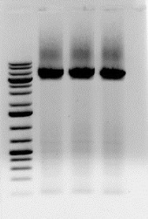

* 1. Third run done at 57C as annealing temp, because higher is generally better if all else is equal. Made 4 tubes, so did a larger master mix:

|  |  |  |
| --- | --- | --- |
| Reagent | Volume (μL) | 4.5x Volume (μL) |
| Water | 33.5 | 150.75 |
| 5X iProof HF Buffer | 10.0 | 45 |
| 10mM dNTPs | 1.0 | 4.5 |
| Fwd primer | 1.0 | 4.5 |
| Rev primer | 1.0 | 4.5 |
| Template | 1.0 | 4.5 |
| iProof polymerase | 0.5 | 2.25 |
| Total Volume: | 50.0 | 225.0 |

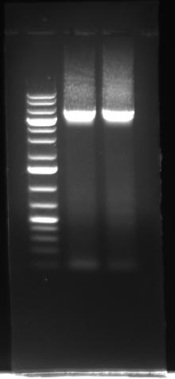

1. Gel purify because the band wasn’t so clear:
   1. Empty tube weight: 6.646
   2. Full tube weight: 7.189
   3. DNA gel weight: 0.543 g (543 mg)